Assignment cover page

Prepared by cse24-144, Shepherd Chitamba

Part A: System Documentation

**1. Requirements Elicitation**

* 1. **Functional Requirements:**

1. **Customer can create multiple accounts**
2. **Customers can deposit and withdraw from appropriate accounts**
3. **Interest is applied to the bank balances at appropriate times**
4. **User authentication is done by username and password (at least 8 characters, alphanumerical)**
5. **Customers can view their accounts’ balances, the system allows for both customers and bank managers**
   1. **Non-Functional Requirements**:
6. **Response time of the system should be expected to be 3ms**
7. **Encryption of data should be handled by the DBMS of choice**
8. **Usability is expected for PC only**
9. **GUI consistency between all sections of the program**
10. **Backup of data should be conducted around midnight on a daily basis**
11. **Structural UML Modelling** 
    1. **System Use Case Diagram**

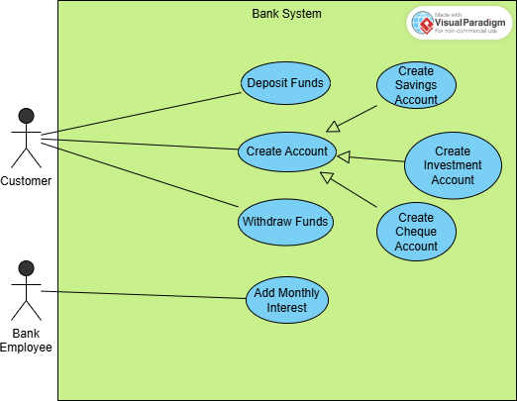

* 1. **Class diagram**

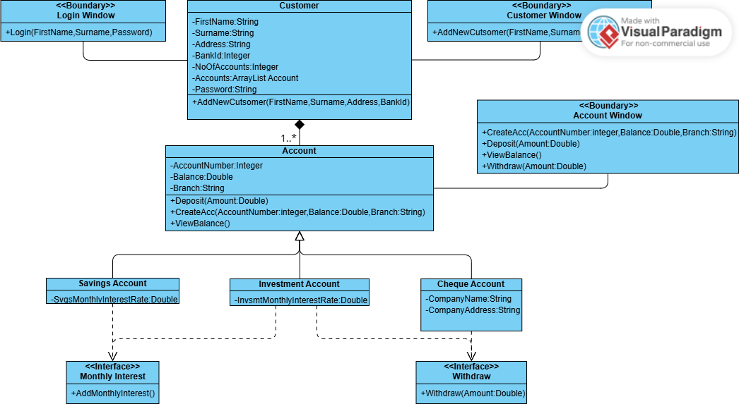

**3. Behavioural UML Modelling)**

**3.1.**  Login and Deposit **Sequence Diagrams:**

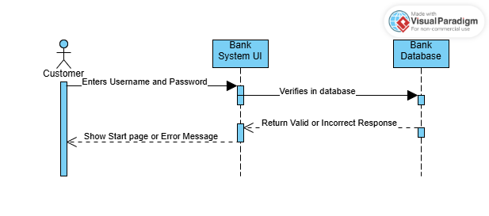

**3.2. State Diagram:**

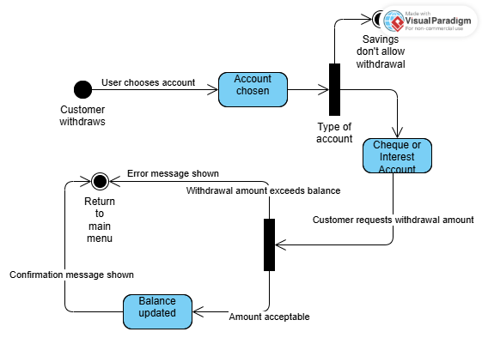

**Meeting record appendix**

**Interviewed by Themba Moeng 9/18/2025 at 18:15**